[](http://www.google.nl/url?sa=i&rct=j&q=&esrc=s&source=images&cd=&cad=rja&uact=8&ved=2ahUKEwjqubL_ycvdAhVRIMUKHXoPBE8QjRx6BAgBEAU&url=http%3A%2F%2Fwww.gezondheidskrant.nl%2Fheeft-voetbal-maatschappelijke-waarde%2F&psig=AOvVaw2GXTMA-IplyvSFNrJgZaBN&ust=1537601459454555)[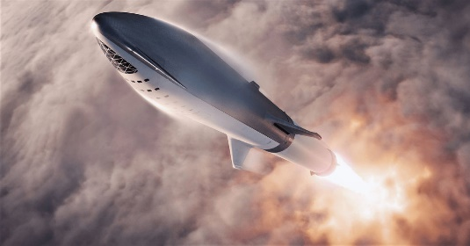](https://www.google.nl/url?sa=i&rct=j&q=&esrc=s&source=images&cd=&cad=rja&uact=8&ved=2ahUKEwi4r6jmycvdAhXtwAIHHX6UCg4QjRx6BAgBEAU&url=https%3A%2F%2Fwww.nytimes.com%2F2018%2F09%2F17%2Fscience%2Fspacex-moon-tourism-passenger.html&psig=AOvVaw0Vr70BdQneKpggEdXcdxyG&ust=1537601418635239)[](https://www.google.nl/url?sa=i&rct=j&q=&esrc=s&source=images&cd=&cad=rja&uact=8&ved=2ahUKEwinxdvAycvdAhXOAewKHaWxC6UQjRx6BAgBEAU&url=https%3A%2F%2Fwww.hiv.gov%2Fblog%2F5-things-to-know-about-instagram-2017&psig=AOvVaw2g08928qaN1cj0K_lnByDo&ust=1537601338005535)[](https://www.google.nl/url?sa=i&rct=j&q=&esrc=s&source=images&cd=&cad=rja&uact=8&ved=2ahUKEwjM2LLYycvdAhWBCOwKHYpQCZwQjRx6BAgBEAU&url=https%3A%2F%2Fplay.google.com%2Fstore%2Fapps%2Fdetails%3Fid%3Dcom.whatsapp%26hl%3Dnl&psig=AOvVaw26NvQgY3PDaDvmQYNEEn4R&ust=1537601391600933)[](https://www.google.nl/url?sa=i&rct=j&q=&esrc=s&source=images&cd=&cad=rja&uact=8&ved=2ahUKEwjyu6qtycvdAhXM_KQKHcoPB1EQjRx6BAgBEAU&url=https%3A%2F%2Fnl-nl.facebook.com%2F&psig=AOvVaw0ww-NTgIF4xf4PeXCRBR3-&ust=1537601299833705)[](https://www.google.nl/url?sa=i&rct=j&q=&esrc=s&source=images&cd=&cad=rja&uact=8&ved=2ahUKEwjl38CeycvdAhXHzqQKHbdpAJ4QjRx6BAgBEAU&url=https%3A%2F%2Fcommons.wikimedia.org%2Fwiki%2FFile%3ATesla_Motors.svg&psig=AOvVaw2xpvj_J3q4D4VpaAIkrsvj&ust=1537601265739798)[](https://www.google.nl/url?sa=i&rct=j&q=&esrc=s&source=images&cd=&cad=rja&uact=8&ved=2ahUKEwjeyJWCycvdAhVKJhoKHcGND_QQjRx6BAgBEAU&url=https%3A%2F%2Fpixabay.com%2Fnl%2Fschild-logo-kuif-304752%2F&psig=AOvVaw2etvdUfcKNce09IlqYiWlC&ust=1537601210603546)