Moodboard Hotwheels

[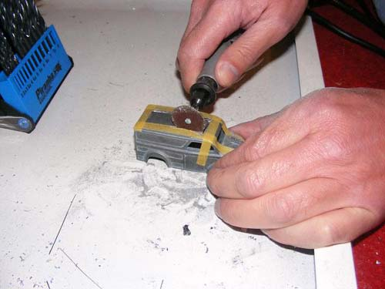](https://www.google.nl/url?sa=i&rct=j&q=&esrc=s&source=images&cd=&cad=rja&uact=8&ved=2ahUKEwiomp-Bk9jdAhXHsKQKHfybBoYQjRx6BAgBEAU&url=https%3A%2F%2Fmancave.conrad.nl%2Fmaak-je-eigen-hot-wheels%2F&psig=AOvVaw0k8XhoRO68QsEbf6qb6ZlT&ust=1538033320332397)[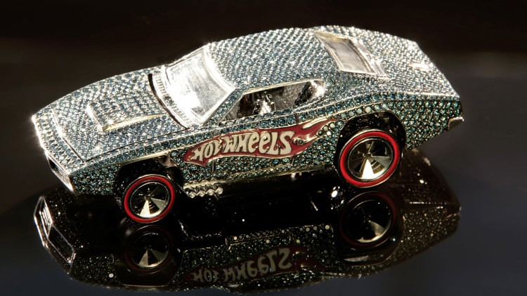](https://www.google.nl/url?sa=i&rct=j&q=&esrc=s&source=images&cd=&cad=rja&uact=8&ved=2ahUKEwjesKXYk9jdAhUB2KQKHezzCTkQjRx6BAgBEAU&url=https%3A%2F%2Fwww.catawiki.nl%2Fstories%2F3947-top-10-duurste-modelauto-s-ooit-gemaakt&psig=AOvVaw11dYvlsAQvYhiT6oBKY00d&ust=1538033570857108)[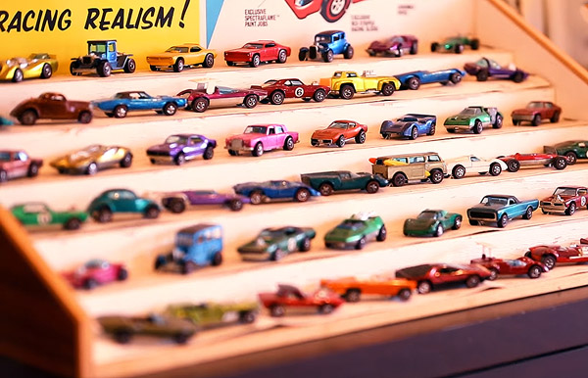](https://www.google.nl/url?sa=i&rct=j&q=&esrc=s&source=images&cd=&cad=rja&uact=8&ved=2ahUKEwiAyvbgktjdAhUhsKQKHZeFDJkQjRx6BAgBEAU&url=https%3A%2F%2Ffreshgadgets.nl%2Fverzamelaar-heeft-voor-meer-dan-een-miljoen-dollar-aan-hot-wheels&psig=AOvVaw0k8XhoRO68QsEbf6qb6ZlT&ust=1538033320332397)[](http://www.google.nl/url?sa=i&rct=j&q=&esrc=s&source=images&cd=&cad=rja&uact=8&ved=2ahUKEwivu8ackNjdAhXSZVAKHZQ0D4kQjRx6BAgBEAU&url=http%3A%2F%2Flogos.wikia.com%2Fwiki%2FFile%3AHot_Wheels_logo.png&psig=AOvVaw1uHm1tujPEY1pKQfS0aMLU&ust=1538032626532534)[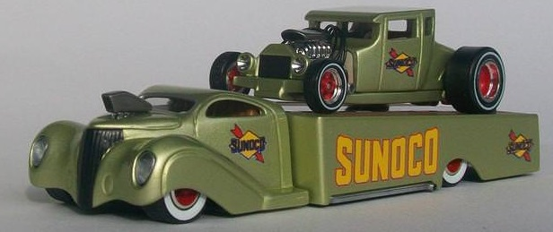](https://www.google.nl/url?sa=i&rct=j&q=&esrc=s&source=images&cd=&cad=rja&uact=8&ved=2ahUKEwi336rOktjdAhVvMewKHZJ-B_kQjRx6BAgBEAU&url=https%3A%2F%2Fforum.hotwheelsverzamelaarsholland.nl%2F&psig=AOvVaw2dHOEkrbOnmUDin4ZNjhDy&ust=1538033102747942)[](https://www.google.nl/url?sa=i&rct=j&q=&esrc=s&source=images&cd=&cad=rja&uact=8&ved=2ahUKEwjks4L-kdjdAhXI_qQKHR0wAF8QjRx6BAgBEAU&url=https%3A%2F%2Ftopgear.nl%2Fautonieuws%2Fhot-wheels-verzameling-1-miljoen%2F&psig=AOvVaw2dHOEkrbOnmUDin4ZNjhDy&ust=1538033102747942)[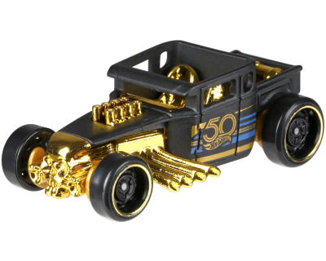](https://www.google.nl/url?sa=i&rct=j&q=&esrc=s&source=images&cd=&cad=rja&uact=8&ved=2ahUKEwiw8KiOkdjdAhWEIlAKHTleD7sQjRx6BAgBEAU&url=https%3A%2F%2Fwww.treinen-paradijs.nl%2Fcatalog%2Fwheels-auto-bone-shaker-p-5462.html&psig=AOvVaw2g7vbcWPpAfV9Ah0EgrS2d&ust=1538032855890871)[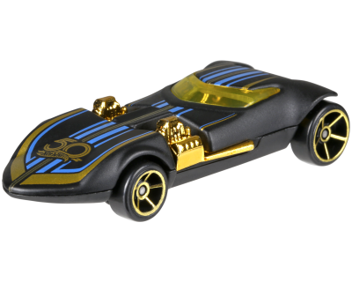](https://www.google.nl/url?sa=i&rct=j&q=&esrc=s&source=images&cd=&cad=rja&uact=8&ved=2ahUKEwiZiqCDkdjdAhVMZlAKHVAiDpsQjRx6BAgBEAU&url=https%3A%2F%2Fwww.treinen-paradijs.nl%2Fcatalog%2Fwheels-auto-twin-mill-p-5461.html&psig=AOvVaw2g7vbcWPpAfV9Ah0EgrS2d&ust=1538032855890871)